Title of presentation
A. Surname¹, B. Surname^{1,2}, and C. Surname³

¹Affiliation corresponding to '1'
²Affiliation corresponding to '2'
³Affiliation corresponding to '3'

Please send a one-page or two-page (maximum) abstract to aux@auxetics.eu and indicate whether an oral or poster presentation is preferred. The name of the presenting/corresponding author should be underlined. Example text of the abstract. Cited reference [1]. Example text of the abstract. Example text of the abstract. Example text of the abstract. Example text of the abstract. Example text of the abstract. Example text of the abstract. Example text of the abstract. Cited references [2,3].
The example of an equation:
$E=mc^{2}$ (1)

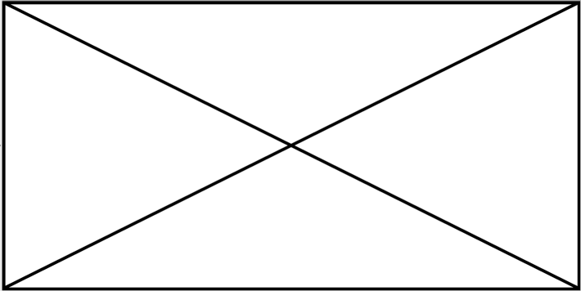
Figure 1: Caption describing a single wide figure.
Figures should be referenced in text as Fig. 1. Acceptable format for figures are jpeg, png or pdf (should be sent with the abstract in a single zip or equivalent archive).
 a) b)
Figure 2: Caption describing a figure a) and b).

Acknowledgements
Optional text if required.

References
- A. Surname and B. Surname , Title, Journal vol. N, pp. 1-8 (YYYY).
- A. Surname et al., Title, Journal vol. N, pp. 17-29 (YYYY).
- A. Surname, Book title, Publisher, place of publishing, YYYY.

